Unit 6 test
Vocabulary
Vocabulary
1 Look, read and tick ().
1 play Frisbee
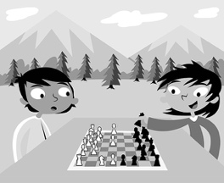 | 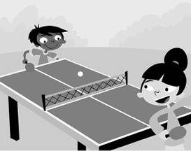 | 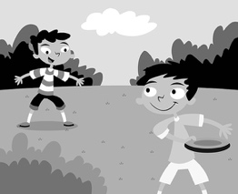
A ☐ | B ☐ | C ☐
2 play tag
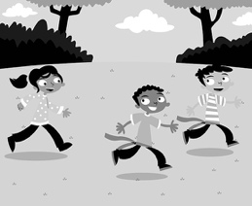 | 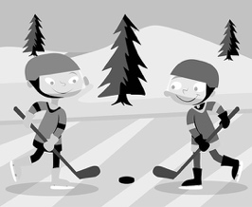 | 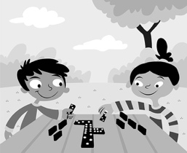
A ☐ | B ☐ | C ☐
3 play hide and seek
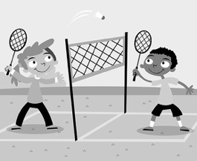 | 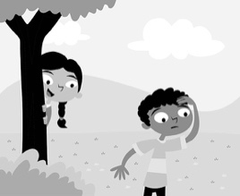 | 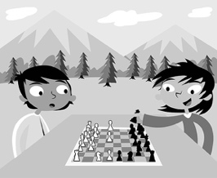
A ☐ | B ☐ | C ☐
/ 3
2 Look, read and number.
 | 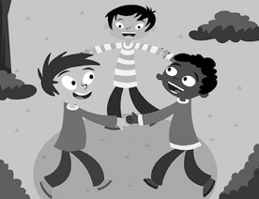 | 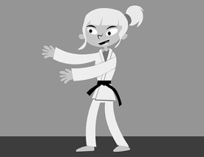 |  | fly a kite  play with friends  read comics  listen to music  do judo  watch TV
1 | 2 | 3
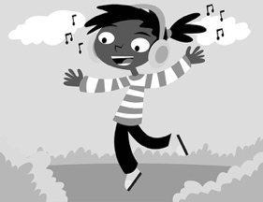 |  | 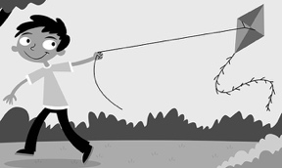
4 | 5 | 6
/ 6
Grammar
3 Look, read and circle.
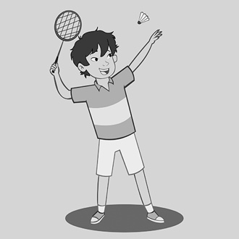 | 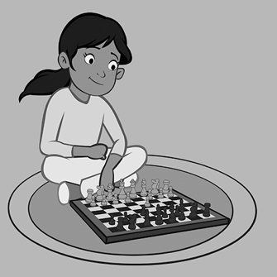 | 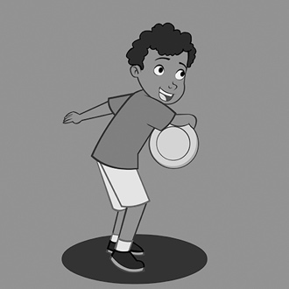
1 What’s he doing?  He’s playing badminton / ice hockey. | 2 What’s she doing?  She’s playing tag  / chess. | 3 What’s he doing?  He’s playing table tennis / Frisbee.
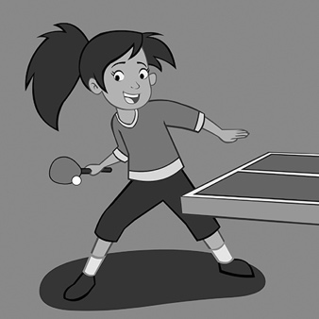 | 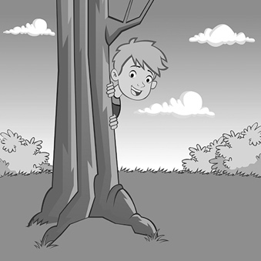 | 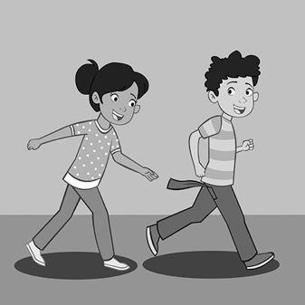
4 What’s she doing?  She’s playing tag /  table tennis. | 5 What’s he doing?  He’s playing ice hockey  / hide and seek. | 6 What are they doing?  They’re playing chess  / tag.
/ 6
4 Read and tick ().
1 Is he doing judo? No, he … .
A ☐ isn’t B ☐ is
2 Is she flying a kite? No, … .
A ☐ he is B ☐ she isn’t
3 Is he reading comics? Yes, … .
A ☐ he is B ☐ she isn’t
4 Is she playing with friends? Yes, … .
A ☐ she is B ☐ he isn’t
/ 4

Reading
5 Read and match the sentence halves.
Hi! My name is Nia. My favourite game is hopscotch. I play hopscotch with my brother Jack and my sister Olivia. I draw squares on the ground with chalk. I draw one square and then two squares. Then I draw one square and two squares again … and again … and again! Jack and Olivia write numbers in the squares. Olivia draws a line in front of square one. Jack is behind the line. He throws a small stick in square one. The stick is in the square! Jack is jumping on one leg to square two … . Oh, Jack jumps on a line! Now, Olivia is throwing a stick! This is a great game!
1 Hopscotch is A with chalk.
2 Jack is Nia’s B front of square one.
3 Nia draws squares C on a line.
4 Olivia draws a line in D Nia’s favourite game.
5 Jack jumps E brother.
/ 5
Writing
6 Write.
closes counts hide opens start tries
How to play hide and seek!
1 We the game.
2 Gurdeep his eyes.
3 We !
4 Gurdeep one, two, three … twenty!
5 Gurdeep his eyes.
6 Gurdeep to find the players.
/ 6

Listening
7  6 Listen and circle the tick () or the cross ().
 | 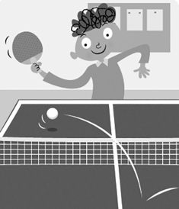 | 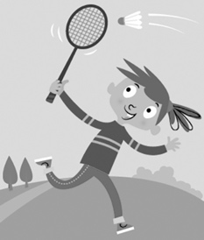
1 / | 2 / | 3 /
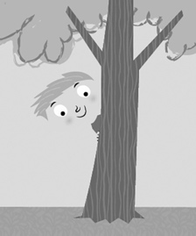 | 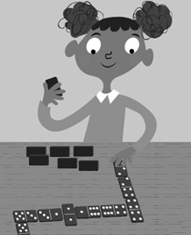
4 / | 5 /
/ 5
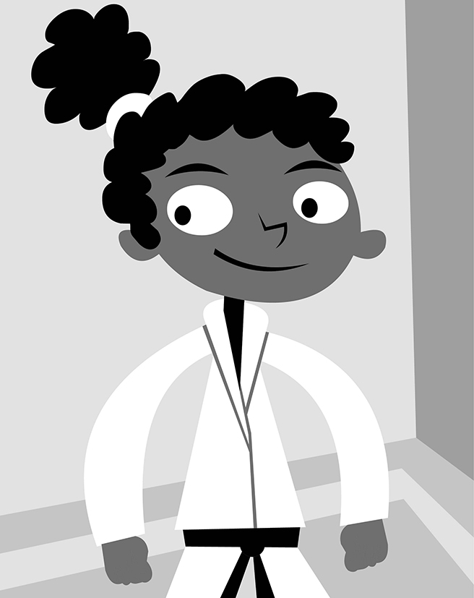
Speaking
8 Look, read and answer.
1 Is Alexia playing with friends?
2 Is she playing a game?
3 Is she doing judo?
4 What games do you like?
5 What’s your favourite game?

/ 5
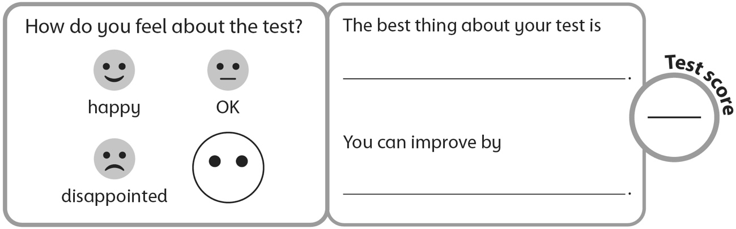
40

